I. Program Name: Welcome

II. Program Description: A program that will display Welcome on screen using ASCII codes.

III. Input/Process/Output:

Input: None

Process: Encoding characters

Output: Display cat character on screen

IV. Flowchart:

Encoded Characters

Display Welcome message

V. Source Code:

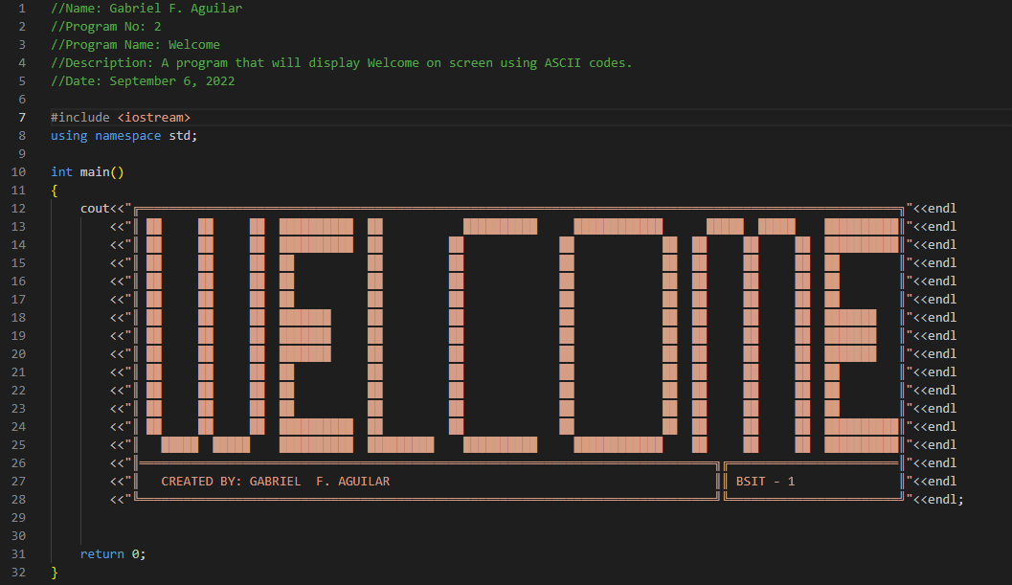

VI. Screenshot:

